**Revision unit 1 2020**

**1)**

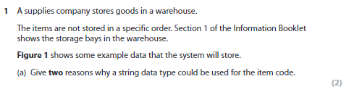1 – because you can use letters to name the items.

2- you can use concatenation.

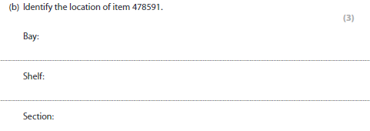

BAY = 01

Shelf = 01

Section = 08

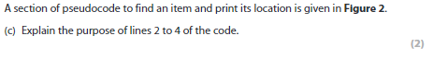Line 2 is used to open a while loop while the length of item is 0.

Line 3 is in the while loop, and it asks the user to input the item required.

Line 4 is used to close the while loop in line 2.

The use of the variable index in the pseudocode is to control the for loop shown on line 5. The values 0 – 999 are assigned to the variable index. Line 6 and 7 in figure 2 shows the values all values being checked against the item requirement which was inputted by the user on line 1.

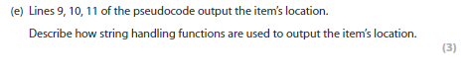The lines in the code check item locations.

Line 9 makes the code pick out the first 2 values in bay. This is done by the code = [0,2]).

Line 10 checks the values placed in position 2 – 4 on the shelf. This is done by the code = [2,4])

